***As a Morehead Star, I…***

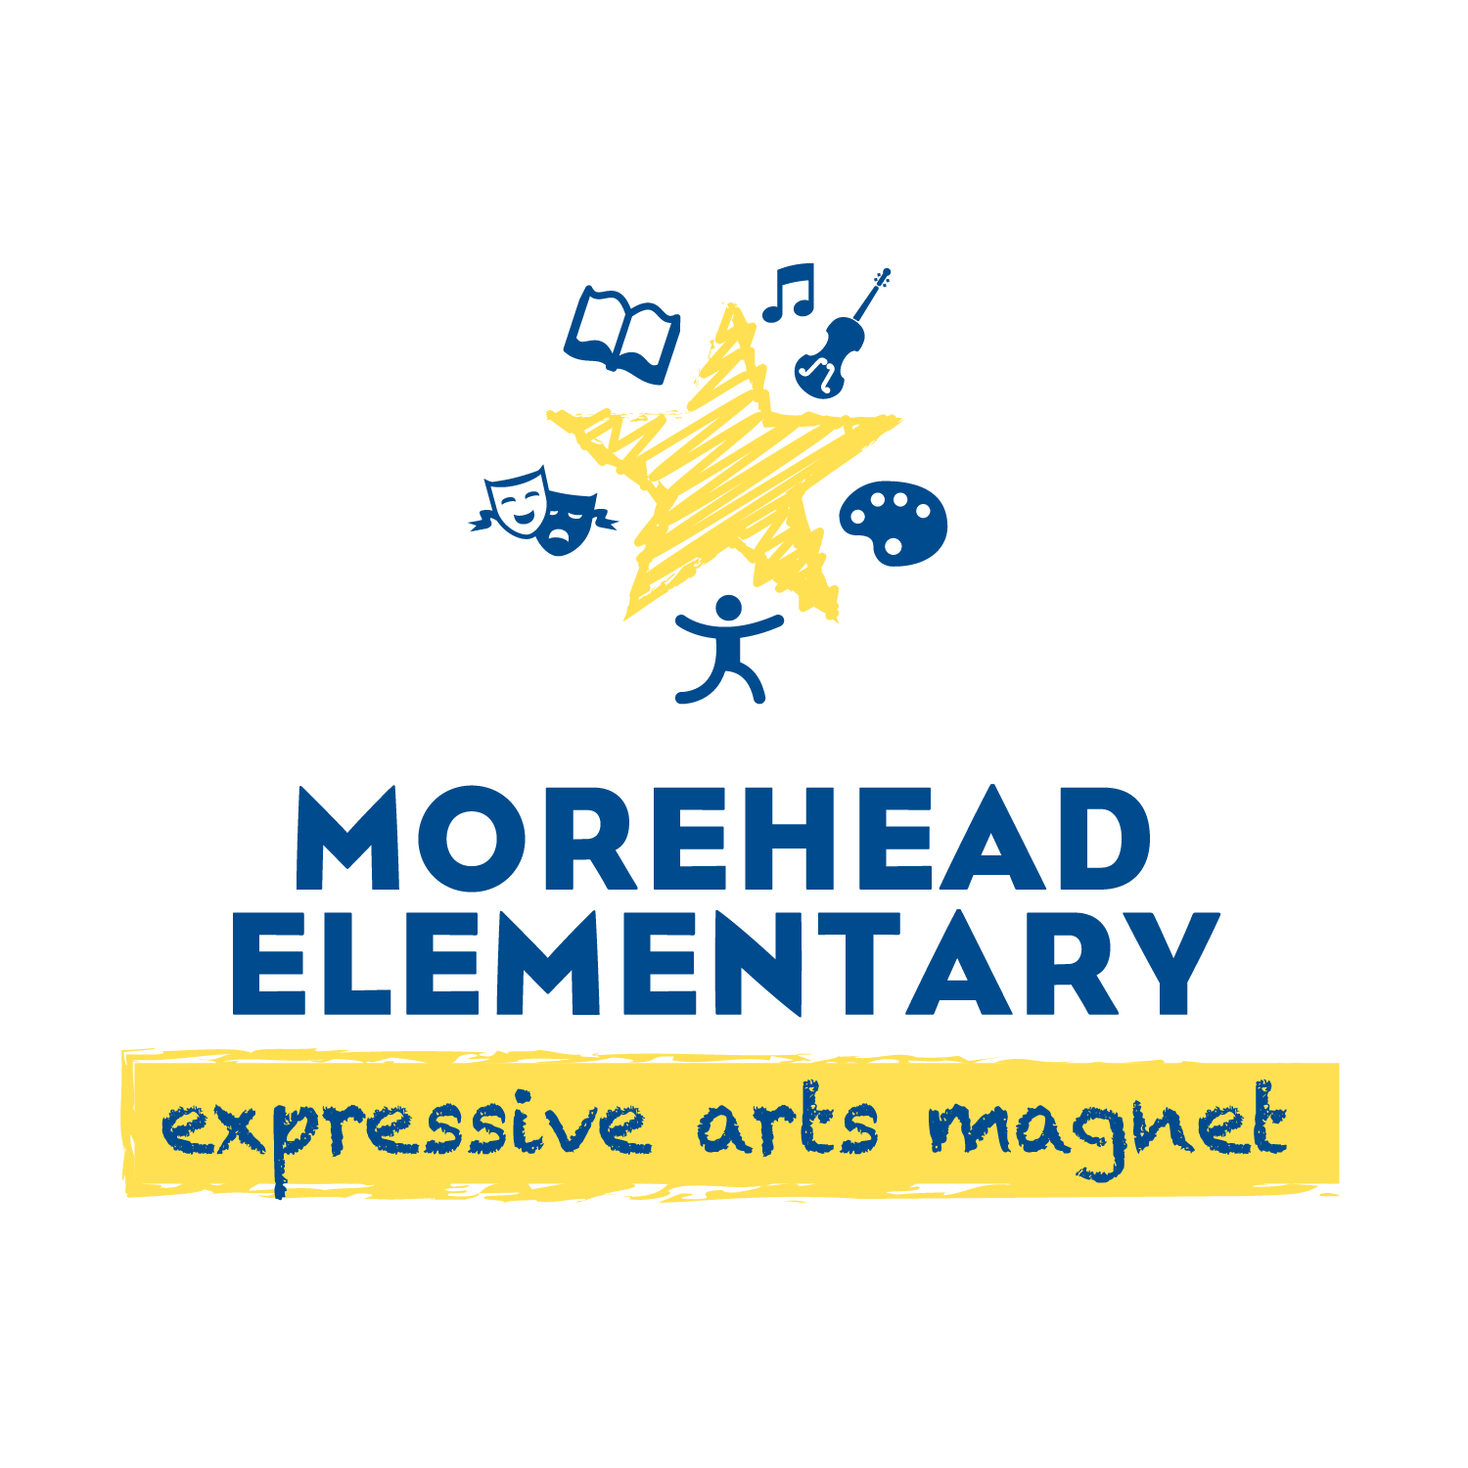**Show Integrity**

* **Stay in my own space.**

**Try My Best**

* **Follow adult’s directions.**
* **Participate fully in all activities.**

**Act Responsibly**

* **Listen with eyes, ears, and body.**
* **Use materials safely and correctly.**

**Respond with Kindness**

* **Use kind words and tone.**
* **Help others.**

**So, success is mine! Success is ours!**